**Waterside Series**

**Marshalling Information**

**Contact Numbers**

Control desk/Retirement/Emergency (Mike Richman) 07870 769687

Emergency 999

Race Organiser (Clive Williams) 07766 904113

Marshall Support Jo Holland 07766 751352

Lynne Hutcheon 07825541334

**Waterside Series Marshall Times**

|  |  |  |  |  |  |  |
| --- | --- | --- | --- | --- | --- | --- |
|  | Check In Times | Start Times | **Race A**  Great\Bedwyn – Newbury 13.5 miles | **Race B**  Newbury – Aldermaston Turn  17 Miles | **Race C**  Pewsey – Newbury  23 Miles | **Race D**  Devizes -Newbury 34 Miles |
| **Race A** | 07:30-11:30 | 09:00-12:00 |  |  |  |  |
| **Race B** | 07:30 - 11:00 | 10:00-12:00 |  |  |  |  |
| **Race C** | 07:30-11:00 | 09:00-11:00 |  |  |  |  |
| **Race D** | 06:00-08:30 | 07:00-08:30 |  |  |  |  |
| **Deivizes** |  |  |  |  |  | 07:00-08:30 |
| **Pewsey** |  |  |  |  | 07:15-11:00 |  |
| **Wooton Rivers** |  |  |  |  | 09:30-11:00 | 09:00-11:30 |
| **Bruce Tunnel** |  |  |  |  | 10:00-12:30 | 09:30-12:00 |
| **Dunmill** |  |  | 09:30-12:45 |  | 11:00-13:30 | 10:45-14:30 |
| **Kintbury** |  |  | 10:00-13:15 |  | 11:30-13:45 | 11:00-14:30 |
| **Hamstead Lock** |  |  | 10:30:13:50 |  | 12:00-14:00 | 11:45-14:30 |
| **WestMills, Town Lock/Finish** |  |  | 10:45-14:30 |  | 12:30-15:00 | 12:15-15:00 |
|  |  |  |  |  |  |  |
| **NCC/Bulls Lock** |  |  |  | 10:45-14:30 |  |  |
| **Woolhampton Swing Bridge/**  **Woolhampton** |  |  |  | 10:45-14:15 |  |  |
| **Aldermaston Turn** |  |  |  | 11:45-13:00 |  |  |
| **Finish NCC** |  |  |  | 12:30-15:30 |  |  |

**Waterside A: Great Bedwyn to Newbury (13.5 Miles)**

|  |  |
| --- | --- |
| Marshalling Points | No. Marshals |
| **Start /carparking Great Bedwyn** | **7** |
| **Dunmill** | **4** |
| **Kintbury** | **6** |
| **Hamstead Lock ./ Marsh Benham** | **4 (potentially 2 for C/D)** |
| **West Mills/Town Lock/Waterside Finish** | **6** |

**Waterside B: Newbury to Aldermaston Turn (17 Miles)**

|  |  |
| --- | --- |
| **Start Newbury Canoe Club** |  |
| **Bulls Lock** | **3** |
| **Woolhampton Swing Bridge/**  **Woolhampton** | **2**  **3** |
| **Aldermaston Turn** | **4** |
| **NCC Finish** | **2** |

**Waterside C - Pewsey Wharf to Newbury (23 Miles)**

|  |  |
| --- | --- |
| **Start /carparking Pewsey Wharf** | **6** |
| **Wooton Rivers** | **2** |
| **Bruce Tunnel** | **6** |
| **Dunmill** | **4** |
| **Kintbury** | **6** |
| **Hamstead Lock / Marsh Benham** | **4 (potentially 2 for C/D)** |
| **West Mills/ Town Lock /Waterside Finish** | **6 6** |

**Waterside D** - **Devises to Newbury (34 Miles)**

|  |  |
| --- | --- |
| **Start Deivizes** | **6** |
| **Wooton Rivers** | **2** |
| **Bruce Tunnel** | **6** |
| **Dunmill** | **4** |
| **Kintbury** | **6** |
| **Hamstead Lock / Marsh Benham** | **4 (potentially 2 for C/D)** |
| **West Mills / Town Lock /Waterside Finish** | **6** |

**Finish for ACD races Newbury Waterside Centre**

**Race B outside Newbury Canoe Club house by A339 Bridge**

**Control Desk (Newbury Waterside centre – Upstairs)**

**Waterside Series Marshalling Information**

Firstlywe also want to take the opportunity to say a massive thank you to you for giving up your time and giving us your help and support for the Newbury Canoe Club.

A quick bit of history - The Waterside Series has been running since 1968 provides a training and qualification races for the Devizes to Westminster annual canoe race (DW). The DW is an endurance marathon of 125 miles with 77 portages, it is the Kayaking equivalent of the London Marathon. Juniors and veterans have a compulsory rest at Newbury everyone else pushes through to Westminster Bridge an impressive site to see the kayaks travelling up the Thames.

**Marshall Instructions**

The Waterside Whatspp group for each race will show the list of Marshals for each race and immediate information for the day including:

* Contact details for Race start, Control desk, First aiders, Marshall Coordinators
* Lead and assistant marshals for each marshalling point
* Weather Forecast
* Course hazards and special instructions

Each marshalling point will have a Lead Marshall and Marshall Assistants. The Lead Marshall will organise the Marshalling Point and the Assistant Marshals. The Control Desk and Marshall Coordinators will be available to contact and attend if needed.

Marshall boxes will be at each Marshalling Point containing:

Hi Viz Jackets (unique to NCC \ AD – please ensure return)

1 x Survival Bag

2 x Space Blankets

Marshall Information Booklet including :

Incident Report Sheets

Time Delay Report Sheets

Ideas and suggestion sheets

Rubbish Bag

Emergency sugar snacks and plasters etc.

Snacks and cold drinks for Marshalls

Plasters and hand sanitisers

**First aiders** are available if required, please contact Control Desk. Do please familiar yourselves with the Concussion Protocol which is detailed in this document, and complete an Incident Form found at the back of the folder, (please leave completed form in folder). Any incidents should be reported to Control Desk and or Marshal Coordinators of assistance is required.

**Incidents** and accidents should be reported to the Lead Marshall, Control Desk and Marshal coordinators if required, the event should be recorded on an Incident Sheet (in back of folder) please complete and leave in the folder.

**Junior competitors** will have support crews following their progress. Any issues with junior competitors please contact their support crew and the control desk.

When you arrive at the marshalling point signs/cones should be out.

**Once in position: Marshals please Whatsapp Waterside Series, so we know everyone is in position**

Once the race has started, it may be necessary to hold paddlers at road crossings, etc. If this has to be done for a significant time, i.e. more than 30 seconds, use the Time Delay Report Sheet (in the Marshalls Box) to make a note of paddler’s number & duration that hey were held for, please pass this information to the Control Desk so this time can be deducted from the paddlers finish time.

**Please be polite and considerate to traffic and other road users.**

Marshalls should inform road users about the race and can politely request they wait whilst competitors cross the road, however care should be taken when directing or holding traffic, as there are rights to stop highway traffic .

Please do not allow support crews to obstruct road or competitors.

**Retirements**, please let Control Desk know if you are informed of any so they are not expected at the finish. Inform the control desk of :

Crew Number - Crew Name - -Retirement Location

**Tail end Charlie (Not always applicable – notification on day)**

When close to end of the days racing the last three boat numbers will be posted on the Waterside WhatsApp. Please post on the Waterside Whats App group the boat numbers as these last 3 competitors pass your marshalling points, this helps to ensure everyone has been accounted for.

When done for the day, it will be helpful if you can collect any signs, cones, etc together and leave them in a convenient place so NCC can pick up OR if you can please take all back to the clubhouse – if you are able to do this please confirm on the Waterside Series Whatsapp – this will help us with clearing up at the end of the day. If you can also have a check for any rubbish that may have been dropped, and put it in the bag provided.

Waterside Series Concussion protocol

1. **Introduction**

This protocol is for race staff. It is designed to explain what concussion is, symptoms of concussion and actions to be taken where concussion is suspected.

1. **What is concussion and why is it a problem?**

A concussion is a type of traumatic brain injury—or TBI—caused by a bump, blow, or jolt to the head or by a hit to the body that causes the head and brain to move rapidly back and forth. This sudden movement can cause the brain to bounce around or twist in the skull, creating chemical changes in the brain and sometimes stretching and damaging brain cells. A concussion injury can affect judgement, awareness and balance.

Such injuries can occur where, for example:

* A paddler hits their head on a low bridge
* A paddler falls, striking their head.
* A paddler is hit in the head by another boat

Most sports (e.g. soccer, rugby, cricket) now operate strict concussion protocols where if a competitor is suspected of incurring a concussion injury they are immediately withdrawn from the game and their condition is monitored. The Waterside Series races presents particular dangers to competitors with a concussion injury given the often remote sections of the course and the particular risk of drowning.

1. **Symptoms of concussion**

The following are usual symptoms of concussion:

* A headache or a feeling of pressure in the head
* Temporary loss of consciousness
* Confusion or feeling as if in a fog
* Memory loss surrounding the traumatic event
* Dizziness
* Ringing in the ears
* Nausea
* Vomiting
* Slurred speech
* Delayed response to questions
* Appearing dazed
* Double vision
* Fatigue

1. **Action to be taken where concussion is suspected**

If a paddler is suspected of being concussed the following action should be taken:

* Explain that you are concerned that they have a concussion injury and ask them to stop paddling and rest. Advise this is for their safety and well being.
* If necessary, advise that continuing to race when unfit can lead to disqualification
* For junior paddlers advise they cannot continue without specific approval of their team leader/lead supporter
* If possible, get support crew details
* Advise race control, giving boat number and describing what has happened

Race control will put a first aider in touch who will speak to the paddler and make an assessment of whether they should continue the race.

If the paddler refuses the advice to stop race control should be advised, giving boat details, timings and why you are concerned.

1. **Red flags**

If ANY of the following are reported or develop, medical attention should be sought as a priority (i.e. consider calling an ambulance)

* Deteriorating conscious state
* Severe or increasing headache
* Unusual behaviour change
* Double vision or deafness
* Increasing confusion or irritability
* Repeated vomiting
* Seizure or convulsion
* Weakness or tingling/burning in arms or legs

1. **Action on stopping**

If the paddler stops the following action should be taken:

* Get the support crew to attend
* Keep the paddler warm, ideally using their change of clothing and emergency blanket
* If possible get them into a warm place (car, building if available).
* On arrival of the support crew get them changed into dry and warm clothes, then taken home or to medical care if required
* Get the support crew to ensure they are assessed by a health care professional within 24 hours of the incident to ensure that there are no significant underlying medical issues
* As soon as practicable rest & sleep – this is good for recovery

The following should not happen:

* Allow them to be left alone. Support crew should keep a watch over them for24 hours
* Consume alcohol in the 24 hours and/or until symptom free
* The injured paddler drives a motor vehicle in the first hours and/or until symptom free.

**Devizes**

**Start**

Number of marshals required:

Check in 3, carpark 3, starters 3

What3Words: ///property.rigs.factually

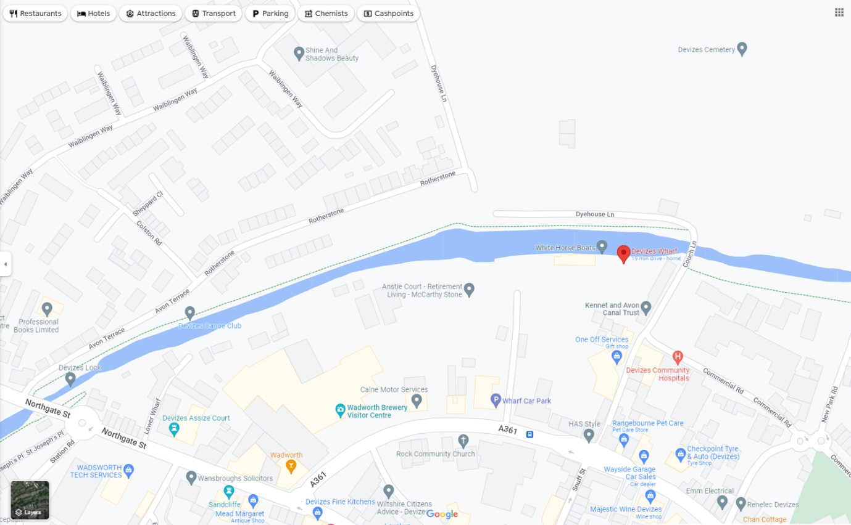

**Wootton Rivers**

**Distance to Finish: 32km \ 19 miles**

Number of marshals required 2

**Marshalling Issues :** Most traffic will be support crews

What3Words: ///glare.schooling.overpaid

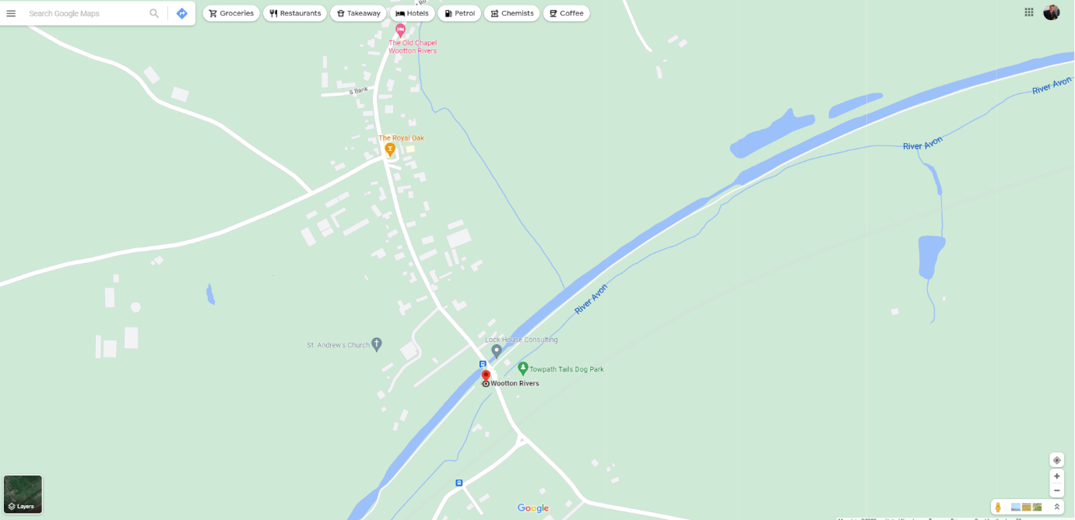

**Bruce Tunnel**

**Air Horn**

Distance to Finish: 28km \ 17 miles

**Marshalling Issues:** Marshalling required at the entrance (3 people) and exit (3 people) of the tunnel, each with an open canoe (with lights) and people able to paddle them in to the tunnel to assist with any capsizes, etc.

1 person needs to be on the bank at the entrance to note any boat numbers and duration that they are held due to being unable to enter the tunnel because of other water traffic. Also will need to count boats in.

Detailed risk assessment and guidelines available

Number of marshals and canoes required 6

West End 2 marshals

East End 2 marshals

Canoe/kayak rescue support 2

What3Words: ///beats.translate.yield

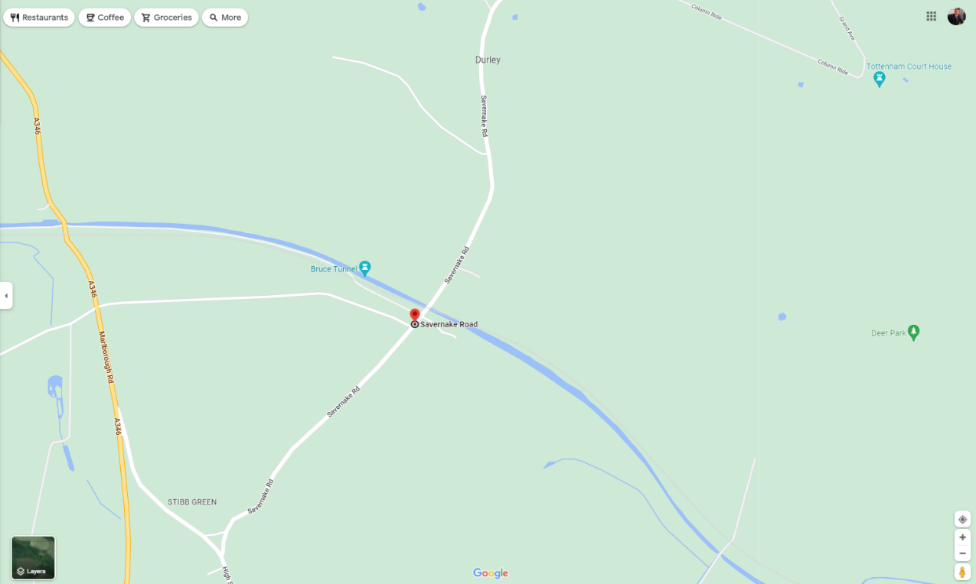

**Dun Mill**

Distance to Finish: 13km \ 8 miles

**Marshalling issues:**

Paddlers have awkward exit from the canal through a kissing gate, and then have to cross over bridge and put in on the other side of the canal. Paddlers will be compensated for time lost with traffic hold ups

Blind bend and frequent traffic

There is a car park for fishermen just up from the lock which has a height restriction.

Number of marshals required 4

What3Words: ///exists.mailers.branch

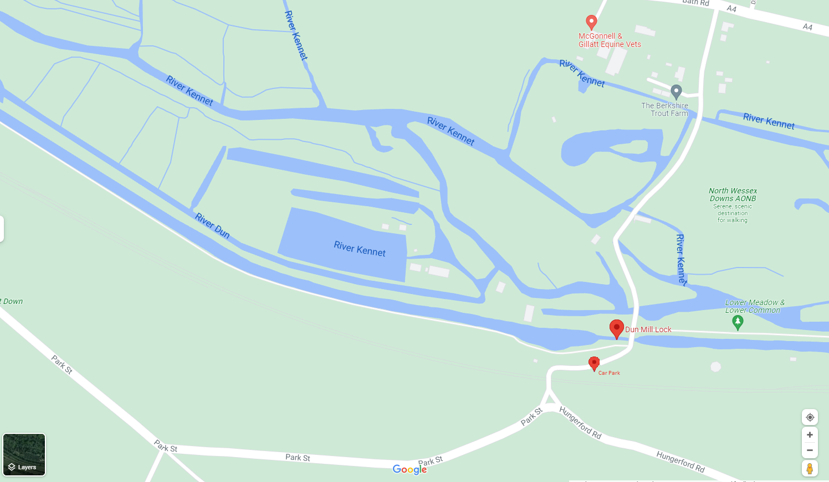

**Kintbury**

Distance to Finish: 8km \ 5 miles

**Marshalling issues:**

Paddlers have awkward exit from the canal through a kissing gate, and then across the bridge to put in on the other side of the canal.

Blind bend railway crossing and frequent traffic

The rail crossing is not immediately obvious to drivers, therefore it is important to ensure drivers have an exit over the canal bridges and do not get held on the level crossing, stop the paddlers crossing when required if rail crossing barriers are activating to ensure safe traffic flow.

Car parking is available in Dundas Arms carpark **only to 11:45**, additional car parking is available opposite, Public toilets are available.

Detailed risk assessment and marshalling details available

Number of marshals required 6

What3Words: ///wobbles.giggle.consoled

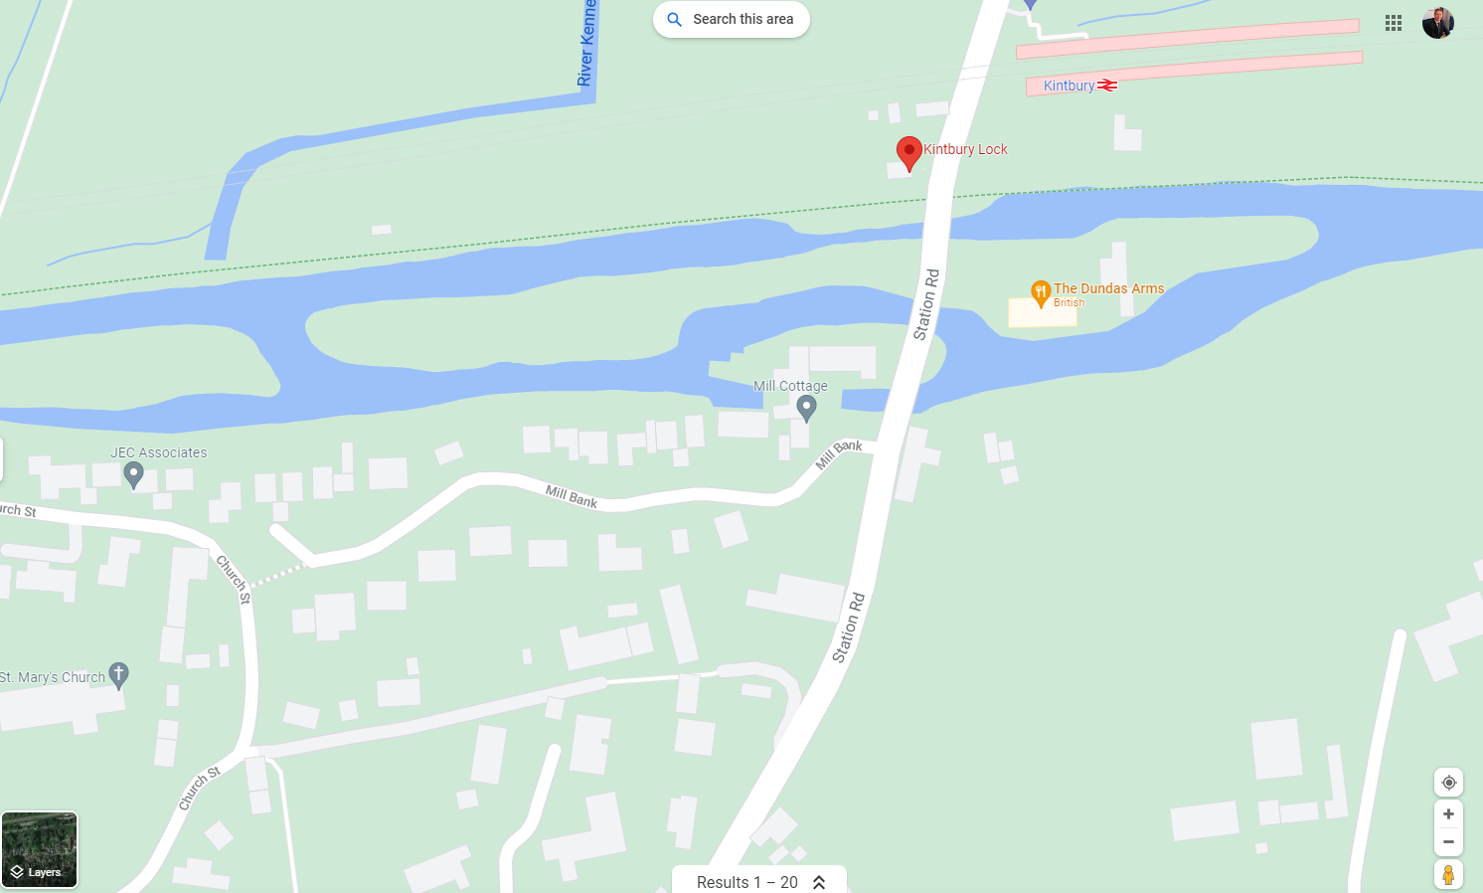

**Hampstead Lock** (Marsh Benham)

Distance to Newbury: 5 km \ 3 miles

**Marshalling issues**:

Humpback bridges and blind bends, support traffic needs to park on North side of railway crossing

Number of marshals required 4 (Potentially 2 for Races C/D)

What3Words: ///stylists.pushy.division

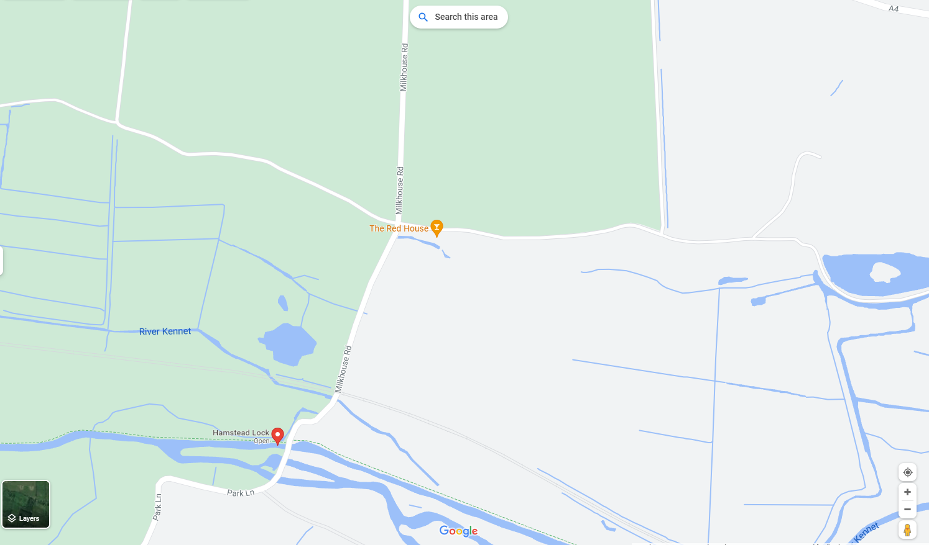

**West Mills Swing Bridge**

**Marshalling issues:** This is a compulsory portage of the bridge. Paddlers should get out & put in on the same side.

pedestrians and warn paddlers of weir on RHS

**Paddlers are not to go over the swing bridge.**

**Newbury Town Lock** (by The Lockstock)

**Marshalling issues:** Care of pedestrians by lock with boats moving through narrow area and barges entering lock and town bridge. Walkie talkie contact with finishers to monitor any barge movement through Town Bridge

Number of marshals required 2

What3Words: ///hill.prime.blame

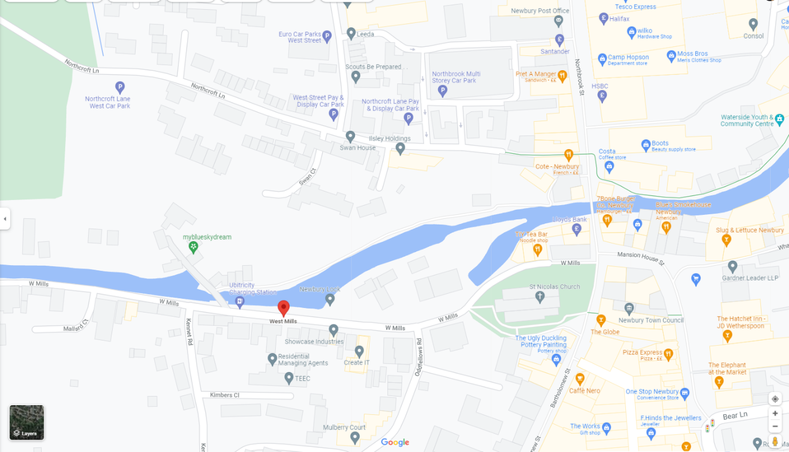

**Bulls Lock**

**(2nd lock down from the club)**

**Marshalling issues:** Protruding beams under bridge

It needs to be a portage for ALL boats around the swing bridge. Paddlers can get back in and paddle to the lock if they want, but it is only a short distance, so easier to portage. Crews are allowed across the swing bridge, so they can portage on either side of the lock.

Number of marshals required 3

What3Words : ///carbon.race.dawn

**Woolhampton – Swing Bridge 10:20 – 14:15**

**(upstream from Row Barge)**

**Marshalling issues:** The swing bridge upstream from the row barge before Woolhampton Lock that is low. If water levels are high this may be a compulsory portage (decision made close to race day). However they still need to be told to slow down get low, protruding beams under bridge.

Number of marshals required 2

**Woolhampton**

**Marshalling issues:**

**We are asking Support Crews NOT to use the pub Car Park.**

For the lock, paddlers decide where they put in after portaging the lock – either immediately after lock, or they can cross the road bridge and put in below Road Bridge. Marshalls should supervise any road crossing to ensure traffic is aware and paddlers are safe to cross. Narrow Boat traffic may also necessitate a longer swing bridge portage.

Number of marshals required 3

What3Words : ///card.eyeliner.tissue

**Aldermaston Turn**

Care required at turn, competitors must go around cone on path.

Normally there are a lot of pedestrians with dogs, children and push chairs and cyclists. so crowd control required. Support crews must not block road access or impede competitors.

Detailed risk assessment and marshalling instructions available

Number of marshals required 4

What3Words : ///hikes.barstool.flood

**All Locks names and locations**

**Devizes to Aldermaston – West to East**

|  |  |  |  |
| --- | --- | --- | --- |
| **Lock No** | **Lock name** | **OS map Ref** | **What 3 words Ref** |
| 51 | **Wooton Locks** |  | **Cobbles.spotted.hospitals** |
| 52 | **Heavy Close Lock** |  | **Cups.cassettes.deluded** |
| 53 | **Brimslade Lock** |  | **Sensibly.lights.baked** |
| 54 | [**Wootton Top Lock**](https://en.wikipedia.org/wiki/Wootton_Top_Lock) **Cadley Lock** | [SU212634](https://geohack.toolforge.org/geohack.php?pagename=List_of_locks_on_the_Kennet_and_Avon_Canal&params=51.369268677281_N_1.6968470351145_W_region:GB_scale:25000) | **Listening.material.finds** |
| 55–63 | [**Crofton Locks**](https://en.wikipedia.org/wiki/Crofton_Locks) | [SU254622](https://geohack.toolforge.org/geohack.php?pagename=List_of_locks_on_the_Kennet_and_Avon_Canal&params=51.358307397227_N_1.636600112742_W_region:GB_scale:25000) | **Punters.womb.buckets** |
| 56 |  |  | **Materials.self.domestic** |
| 57 |  |  | **Dispensed.splits.unframed** |
| 58 |  |  | **Local.shredding.inspects** |
| 59 |  |  | **Trample.crass.remission** |
| 60 |  |  | **Tempting.messy.clouds** |
| 61 |  |  | **Directors.clearly.medium** |
| 62 |  |  | **Hulk.lectured.tolerates** |
| 63 |  |  | **Tight.masterful.minds** |
| 64 | [**Bedwyn Church Lock**](https://en.wikipedia.org/wiki/Bedwyn_Church_Lock) | [SU278641](https://geohack.toolforge.org/geohack.php?pagename=List_of_locks_on_the_Kennet_and_Avon_Canal&params=51.375279260126_N_1.6019849478144_W_region:GB_scale:25000) | **Emulating.worldwide.remarked** |
| 65 | [**Burnt Mill Lock**](https://en.wikipedia.org/wiki/Burnt_Mill_Lock) | [SU283649](https://geohack.toolforge.org/geohack.php?pagename=List_of_locks_on_the_Kennet_and_Avon_Canal&params=51.382447797823_N_1.594738165764_W_region:GB_scale:25000) | **Immune.internal.pepper** |
| 66 | [**Potter's Lock**](https://en.wikipedia.org/wiki/Potter%27s_Lock,_Wiltshire) | [SU288654](https://geohack.toolforge.org/geohack.php?pagename=List_of_locks_on_the_Kennet_and_Avon_Canal&params=51.38691845244_N_1.5875133531806_W_region:GB_scale:25000) | **Defers.bangle.clinking** |
| 67 | [**Little Bedwyn Lock**](https://en.wikipedia.org/wiki/Little_Bedwyn_Lock) | [SU290659](https://geohack.toolforge.org/geohack.php?pagename=List_of_locks_on_the_Kennet_and_Avon_Canal&params=51.39140400688_N_1.5845986246684_W_region:GB_scale:25000) | **Prefix.pairings.sway** |
| 68 | **Froxfiled Top Lock** [**Oakhill Down Lock**](https://en.wikipedia.org/wiki/Oakhill_Down_Lock) | [SU299671](https://geohack.toolforge.org/geohack.php?pagename=List_of_locks_on_the_Kennet_and_Avon_Canal&params=51.402147121522_N_1.5715634419452_W_region:GB_scale:25000) | **Hurtles.divide.smothered** |
| 69 | [**Froxfield Middle Lock**](https://en.wikipedia.org/wiki/Froxfield_Middle_Lock) | [SU301674](https://geohack.toolforge.org/geohack.php?pagename=List_of_locks_on_the_Kennet_and_Avon_Canal&params=51.404833990667_N_1.5686630865645_W_region:GB_scale:25000) | **Windows.presitge.distilled** |
| 70 | [**Froxfield Bottom Lock**](https://en.wikipedia.org/wiki/Froxfield_Bottom_Lock) | [SU303676](https://geohack.toolforge.org/geohack.php?pagename=List_of_locks_on_the_Kennet_and_Avon_Canal&params=51.406621651096_N_1.5657709016551_W_region:GB_scale:25000) | **Enlarge.prevented.blanks** |
| 71 | [**Picketfield Lock**](https://en.wikipedia.org/wiki/Picketfield_Lock) | [SU315680](https://geohack.toolforge.org/geohack.php?pagename=List_of_locks_on_the_Kennet_and_Avon_Canal&params=51.410153037536_N_1.5484838765426_W_region:GB_scale:25000) | **Zeal.gearbox.taxed** |
| 72 | [**Cobbler's Lock**](https://en.wikipedia.org/wiki/Cobbler%27s_Lock) | [SU321684](https://geohack.toolforge.org/geohack.php?pagename=List_of_locks_on_the_Kennet_and_Avon_Canal&params=51.413716032982_N_1.5398213278858_W_region:GB_scale:25000) | **Conned.absorbs.agreeable** |
| 73 | [**Hungerford Marsh Lock**](https://en.wikipedia.org/wiki/Hungerford_Marsh_Lock) | [SU326685](https://geohack.toolforge.org/geohack.php?pagename=List_of_locks_on_the_Kennet_and_Avon_Canal&params=51.414586733721_N_1.5326228928886_W_region:GB_scale:25000) | **Burns.chugging.straying** |
| 74 | [**Hungerford Lock**](https://en.wikipedia.org/wiki/Hungerford_Lock) | [SU336687](https://geohack.toolforge.org/geohack.php?pagename=List_of_locks_on_the_Kennet_and_Avon_Canal&params=51.416326806414_N_1.5182252110674_W_region:GB_scale:25000) | **Incursion.warns.sideboard** |
| 75 | [**Dun Mill Lock**](https://en.wikipedia.org/wiki/Dun_Mill_Lock) | [SU352683](https://geohack.toolforge.org/geohack.php?pagename=List_of_locks_on_the_Kennet_and_Avon_Canal&params=51.412633540707_N_1.4952579336148_W_region:GB_scale:25000) | **Jiggle.downs.alas** |
| 76 | [**Wire Lock**](https://en.wikipedia.org/wiki/Wire_Lock) | [SU363681](https://geohack.toolforge.org/geohack.php?pagename=List_of_locks_on_the_Kennet_and_Avon_Canal&params=51.410766157167_N_1.479462441821_W_region:GB_scale:25000) | **Depth.abruptly.suave** |
| 77 | [**Brunsden Lock**](https://en.wikipedia.org/wiki/Brunsden_Lock) | [SU372676](https://geohack.toolforge.org/geohack.php?pagename=List_of_locks_on_the_Kennet_and_Avon_Canal&params=51.406212398748_N_1.4665749992213_W_region:GB_scale:25000) | **Venturing.interests.score** |
| 78 | [**Kintbury Lock**](https://en.wikipedia.org/wiki/Kintbury_Lock) | [SU386671](https://geohack.toolforge.org/geohack.php?pagename=List_of_locks_on_the_Kennet_and_Avon_Canal&params=51.401623521482_N_1.4465028389352_W_region:GB_scale:25000) | **Pull.irony.mermaids** |
| 79 | [**Dreweatt's Lock**](https://en.wikipedia.org/wiki/Dreweatt%27s_Lock) | [SU411673](https://geohack.toolforge.org/geohack.php?pagename=List_of_locks_on_the_Kennet_and_Avon_Canal&params=51.403246608524_N_1.4105435219418_W_region:GB_scale:25000) | **Twinkled.breakfast.glow** |
| 80 | [**Copse Lock**](https://en.wikipedia.org/wiki/Copse_Lock) | [SU416670](https://geohack.toolforge.org/geohack.php?pagename=List_of_locks_on_the_Kennet_and_Avon_Canal&params=51.400512917622_N_1.4033911224352_W_region:GB_scale:25000) | **Opened.bravo.reliving** |
| 81 | [**Hamstead Lock**](https://en.wikipedia.org/wiki/Hamstead_Lock) | [SU424671](https://geohack.toolforge.org/geohack.php?pagename=List_of_locks_on_the_Kennet_and_Avon_Canal&params=51.401352953405_N_1.3918799440603_W_region:GB_scale:25000) | **Croaking.headed.knots** |
| 82 | [**Benham Lock**](https://en.wikipedia.org/wiki/Benham_Lock) | [SU438665](https://geohack.toolforge.org/geohack.php?pagename=List_of_locks_on_the_Kennet_and_Avon_Canal&params=51.395852205836_N_1.3718298073251_W_region:GB_scale:25000) | **Forget.shock.give** |
| 83 | [**Higg's Lock**](https://en.wikipedia.org/wiki/Higg%27s_Lock) | [SU447667](https://geohack.toolforge.org/geohack.php?pagename=List_of_locks_on_the_Kennet_and_Avon_Canal&params=51.397580399852_N_1.3588694076087_W_region:GB_scale:25000) | **Stump.loft.elaborate** |
| 84 | [**Guyer's Lock**](https://en.wikipedia.org/wiki/Guyer%27s_Lock) | [SU453669](https://geohack.toolforge.org/geohack.php?pagename=List_of_locks_on_the_Kennet_and_Avon_Canal&params=51.39933113347_N_1.3502201158686_W_region:GB_scale:25000) | **Yards.rocks.easy** |
| 85 | [**Newbury Town Lock**](https://en.wikipedia.org/wiki/Newbury_Lock) | [SU470671](https://geohack.toolforge.org/geohack.php?pagename=List_of_locks_on_the_Kennet_and_Avon_Canal&params=51.40099136594_N_1.3257586913719_W_region:GB_scale:25000) | **Slices.gift.frame** |
| 86 | [**Greenham Lock**](https://en.wikipedia.org/wiki/Greenham_Lock)[**[B]**](https://en.wikipedia.org/wiki/List_of_locks_on_the_Kennet_and_Avon_Canal#endnote_KennetB) | [SU480673](https://geohack.toolforge.org/geohack.php?pagename=List_of_locks_on_the_Kennet_and_Avon_Canal&params=51.402706017372_N_1.3113576978253_W_region:GB_scale:25000) | **Flies.mats.rush** |
| 87 | [**Ham Lock**](https://en.wikipedia.org/wiki/Ham_Lock)[**[B]**](https://en.wikipedia.org/wiki/List_of_locks_on_the_Kennet_and_Avon_Canal#endnote_KennetB) | [SU487672](https://geohack.toolforge.org/geohack.php?pagename=List_of_locks_on_the_Kennet_and_Avon_Canal&params=51.401747390956_N_1.3013092405923_W_region:GB_scale:25000) | **Herds.ranked.boost** |
| 88 | [**Bull's Lock**](https://en.wikipedia.org/wiki/Bull%27s_Lock)[**[B]**](https://en.wikipedia.org/wiki/List_of_locks_on_the_Kennet_and_Avon_Canal#endnote_KennetB) | [SU499667](https://geohack.toolforge.org/geohack.php?pagename=List_of_locks_on_the_Kennet_and_Avon_Canal&params=51.397147871664_N_1.2841304107943_W_region:GB_scale:25000) | **Native.holds.pump** |
| 89 | [**Widmead Lock**](https://en.wikipedia.org/wiki/Widmead_Lock)[**[B]**](https://en.wikipedia.org/wiki/List_of_locks_on_the_Kennet_and_Avon_Canal#endnote_KennetB) | [SU508663](https://geohack.toolforge.org/geohack.php?pagename=List_of_locks_on_the_Kennet_and_Avon_Canal&params=51.393471813875_N_1.2712521335095_W_region:GB_scale:25000) | **Space.result.votes** |
| 90 | [**Monkey Marsh Lock**](https://en.wikipedia.org/wiki/Monkey_Marsh_Lock)[**[B]**](https://en.wikipedia.org/wiki/List_of_locks_on_the_Kennet_and_Avon_Canal#endnote_KennetB) | [SU522662](https://geohack.toolforge.org/geohack.php?pagename=List_of_locks_on_the_Kennet_and_Avon_Canal&params=51.39244593079_N_1.2511467673172_W_region:GB_scale:25000) | **Hiring.army.speeded** |
| 91 | [**Colthrop Lock**](https://en.wikipedia.org/wiki/Colthrop_Lock)[**[B]**](https://en.wikipedia.org/wiki/List_of_locks_on_the_Kennet_and_Avon_Canal#endnote_KennetB) | [SU538663](https://geohack.toolforge.org/geohack.php?pagename=List_of_locks_on_the_Kennet_and_Avon_Canal&params=51.393195876775_N_1.22813794485_W_region:GB_scale:25000) | **Grading.flattered.blessing** |
| 92 | [**Midgham Lock**](https://en.wikipedia.org/wiki/Midgham_Lock)[**[B]**](https://en.wikipedia.org/wiki/List_of_locks_on_the_Kennet_and_Avon_Canal#endnote_KennetB) | [SU548662](https://geohack.toolforge.org/geohack.php?pagename=List_of_locks_on_the_Kennet_and_Avon_Canal&params=51.392201295163_N_1.2137821090626_W_region:GB_scale:25000) | **Lived.mimics.digested** |
| 93 | [**Heale's Lock**](https://en.wikipedia.org/wiki/Heale%27s_Lock)[**[B]**](https://en.wikipedia.org/wiki/List_of_locks_on_the_Kennet_and_Avon_Canal#endnote_KennetB) | [SU562663](https://geohack.toolforge.org/geohack.php?pagename=List_of_locks_on_the_Kennet_and_Avon_Canal&params=51.39296370836_N_1.1936470990664_W_region:GB_scale:25000) | **Tastes.reply.sped** |
| 94 | [**Woolhampton Lock**](https://en.wikipedia.org/wiki/Woolhampton_Lock)[**[B]**](https://en.wikipedia.org/wiki/List_of_locks_on_the_Kennet_and_Avon_Canal#endnote_KennetB) | [SU571665](https://geohack.toolforge.org/geohack.php?pagename=List_of_locks_on_the_Kennet_and_Avon_Canal&params=51.394672170091_N_1.180681042514_W_region:GB_scale:25000) | **Aquatics.cage.steady** |
| 95 | [**Aldermaston Lock**](https://en.wikipedia.org/wiki/Aldermaston_Lock)[**[B]**](https://en.wikipedia.org/wiki/List_of_locks_on_the_Kennet_and_Avon_Canal#endnote_KennetB) | [SU601671](https://geohack.toolforge.org/geohack.php?pagename=List_of_locks_on_the_Kennet_and_Avon_Canal&params=51.399757271437_N_1.1374652691409_W_region:GB_scale:25000) | **Blessing.walls.functions** |